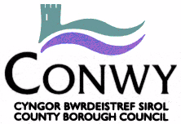
No Ball Games Sign Removal Request Form

By completing this form you are requesting the removal of a no ball games sign in your community. This form is for internal
use only and will not be made public. After you submit your form an assessment will be made about the suitability of removal.

Name: __________________________________________________
Contact number: __________________________________________________
Contact email: __________________________________________________
I would prefer to remain anonymous
I am a resident/community group/professional working in the area

Location of sign _____________________________________________________________ Postcode ________________

Description of sign and surrounding area (attach a picture if possible)

Why should this sign be removed?

Is there community support for this removal YES/ NO/ NOT SURE

Are there any busy roads nearby? YES/NO
If YES, please provide further comments…

Are there any properties nearby? YES/NO
If YES, please provide further comments…

Are there any other spaces for children to play nearby YES/NO
If YES, what spaces are available…
I wish to stay informed about the progress of my request to remove the sign

Please return to
playdevelopment@cvsc.org.uk or Play Development, CVSC, 7 Rhiw Road, Colwyn Bay, LL29 7TG

