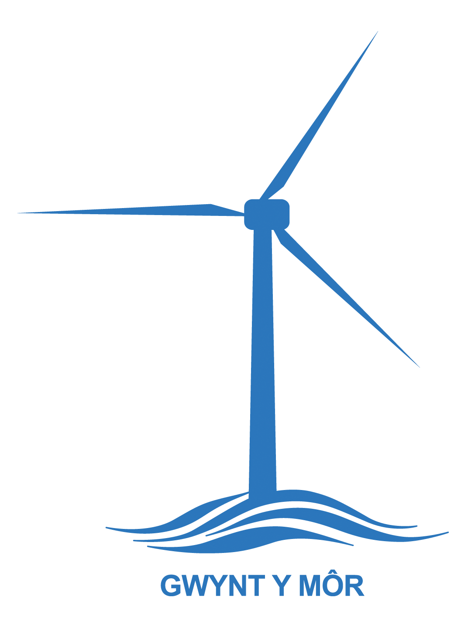

Gwynt y Môr Community Fund
Small Grant Application Form

Make sure you have read the Guidelines for Applicants before you complete this application. Please submit the application in Word document if typed, if handwritten please use black ink.
Please answer every question. Where the question is not appropriate to your organisation or project please write Not Applicable (N/A)

For Office Use Only:
Reference number..................... Date of receipt.........................

Section 1: About Your Organisation

Name of organisation

Address of your organisation | Post Code:
Contact details of person responsible for the project | Name:  Role in organisation:  Telephone:  E-mail address:  Postal Address
Are you a part of a wider organisation/affiliated to any National Governing Body?

Yes No

If yes please state which organisation/body……………………………………………………
Please describe your organisation type (charity/social enterprise/community group)  Your organisations main purpose/goals  -Mission statement or general area of work  Your geographical area of work - Local community, county, regional, national | Charity number (if applicable) …………………………  Company number (if applicable)………………………….
Is membership of your organisation and the project open to anyone who wants to join?

Yes No

If No please explain why?

How many paid staff do you employ?  How many volunteers do you have? | Full time: Part time:  Volunteers:

Section 2: About your project

Project title:

Start date:

End date:

Please describe your proposed project – (What are you going to do? How are you going to achieve it? What exactly will the funding be used for? Who do you work with?)
Why do you need to do this project? (You must show evidenced need, ideally from community / service users. Identify there is no duplication / that demand exceeds supply of this service)

What is the community benefit of this project? (What difference will it make? How many beneficiaries will there be? Who will benefit? What are the short and long term benefits?)

Targets/Outcomes (Please give measurable targets and any soft outcomes identified too
and how will these be measured? Include volunteer recruitment and job creation/retention if applicable)

Support for the project? (Please include with your application letters/emails/quotes of support
from both service users/local community and or other organisations / key partners)

Section 3: Project Financial Details

Expenditure | Cost  £ | VAT  £ | Total  £
Total Project Costs =

Other Grants Applied for/received
(Please list and confirm if received/approved, we will need to see confirmation of this) =

Gwynt y Môr grant requested =

Is your Organisation registered for V.A.T.? | Yes No  If yes; you will be expected to reclaim V.A.T. on your project and any grant paid will exclude the V.A.T. element

Section 4: Project Check List

Please ensure the following documents have been included as part of your application

- Copy of organisation constitution

- Equal Opportunities, Language and Safeguarding policy (if required)

- Written quotes or estimates

- Copy of last available accounts

- Bank Statement

- Evidence/letters of community support for project (5 max)

- Copy of building lease/ownership (if required)

- Copy of planning permission or listed building consent (if required)

If any of these are not included please send a covering note as to why/or when they will be received

Bank Details

Account Name:

Bank name & Address:

Sort Code: Account No.

I/we confirm that our internal financial procedures require a minimum of two signatories (must not be related) per financial transaction ……………………………………………..
Names of authorised signatories:…………………………………………………………..
……………………………………………………………
.

To be completed by a representative of the organisation/group:

I confirm that this application is submitted with the full knowledge and approval of the management committee / directors or trustees of this organisation

I confirm that all the information on this form is true and correct.

Representative’s name: | Position:
Phone No.: | E-mail:
Signature: | Date:

Community and Voluntary Support Conwy (CVSC) operating on behalf of Gwynt y Mor, will use your personal information in order to process your funding application, and will be entered on a database utilised by CVSC and its Third Sector Support Wales partners (further information and our privacy notice are available from https://thirdsectorsupport.wales/privacy/). The information will be held for the length of the GYM project and then destroyed securely

Please return completed Application Form and supporting documents to:

Grants@cvsc.org.uk

CVSC
7 Rhiw Road
Colwyn Bay
Conwy
LL29 7TG

For further help or advice please contact:

Grants Team 01492 523845 email: grants@cvsc.org.uk

About Gwynt y Môr Wind Farm

- Gwynt y Môr was opened in 2015 as the world’s second largest offshore wind farm with the potential of generating enough clean energy for up to 400,000 average UK households each year.
- Over £90 million was spent within Wales and 700 jobs were created during the two year construction period alone.
- Now fully operational, Gwynt y Môr delivers an annual community fund worth over £19 million over its lifetime. The unique selling point is its “community ethos”. It is flexible funding, located in the community, for the community and run by the community.

To find out more about how the Gwynt y Mor Community Fund is making an impact locally, visit the dedicated page on

 @Gwyntymor  @GwyntymorCF

