Gwynt y Môr Community Fund
Small Grant Application Form
Grant from £1,500 up to £20,000

Make sure you have read the Gwynt y Môr Applicant Guidelines before you complete this application.

- Please submit the application via e-mail in Word document if typed.
- Handwritten forms must be in black ink.
- Please answer every question.
- Where the question is not appropriate to your organisation or project, please write ‘Not Applicable (N/A)’

Project Check List

Before you start your application, please ensure to include the following documents:

- Copy of organisation’s constitution / governing document

- Equal Opportunities, Language and Safeguarding policy (if required for this application)

- Written quotes or estimates

- Copy of last available accounts

- Copy of latest Bank Statement

- Evidence/letters of community support for project (5 max)

- Copy of building lease/ownership (if required)

- Copy of planning permission or listed building consent (if required)

- Evidence of project need (community consultations, feedback etc)

If any of these are not included, please send a covering note as to why/or when they will be received.

Section 1: About Your Organisation

Organisation name:

Organisation address: | Post Code:
Organisation e-mail / phone (if applicable) | E-mail:  Phone:
Applicants contact information: | Name:  Role in organisation:  E-mail address:  Phone:  Mobile:
Are you a part of a wider organisation/affiliated to any National Governing Body?

Yes No

If yes please state which organisation/body:

Is your organisation a member of CVSC?

Yes No

Please describe your organisation type (charity/social enterprise/community group) | Charity number (if applicable):  Company number (if applicable):
Your organisations main purpose/goals

Mission statement or general area of work

Your geographical area of work - Local community, county, regional, national

Is membership of your organisation and the project open to anyone who wants to join?

Yes No

If No please explain why?

How many paid staff do you employ?  How many volunteers do you have? | Full time: Part time:  Volunteers:

Section 2: About your project

Project title:

Start date:

End date:

Please select which theme / themes your project will deliver on:

Theme 1: Building strong, cohesive and sustainable communities

Theme 2: Developing prosperous, enterprising communities with strong economic growth

Theme 3: Reducing poverty and inequality in communities

Please describe your proposed project – (What are you going to do? How are you going to achieve it? What exactly will the funding be used for? Who do you work with? Which Gwynt y Môr theme(s) does your project adhere to? Please see the guidelines for applicants).

Why do you need to do this project? (You must show evidenced need, ideally from community / service users. Identify there is no duplication / that demand exceeds supply of this service)

What is the community benefit of this project? (What difference will it make? How many beneficiaries will there be? Who will benefit? What are the short- and long-term benefits?)

Targets/Outcomes (Please give measurable targets and any soft outcomes identified too
and how will these be measured? Include volunteer recruitment and job creation/retention if applicable. Please ensure your project outcomes are realistic and achievable)

Support for the project? (Please include with your application letters/emails/quotes of support
from both service users/local community and or other organisations / key partners)

Section 3: Project Financial Details

Expenditure | Cost  £ | VAT  £ | Total  £
 |  |  | 0
 |  |  | 0
 |  |  | 0
 |  |  | 0
 |  |  | 0
 |  |  | 0
 |  |  | 0
 |  |  | 0
 |  |  | 0
 |  |  | 0
Total Project Costs = |  |  | 0.00
Match funding (Please list, if approved - we will need to see confirmation) =

Gwynt y Môr grant requested =

Is your Organisation registered for V.A.T.? | Yes No  If yes; you will be expected to reclaim V.A.T. on your project and any grant paid will exclude the V.A.T. element

Have you received funding from the Gwynt y Môr Wind Farm Fund in the last 3 years?

Yes ☐ No ☐

Date approved: Project reference:

Bank Details

Account Name:

Bank name & Address:

Sort Code: Account No.

I/we confirm that our internal financial procedures require a minimum of two signatories (must not be related) per financial transaction -
Names of authorised signatories – 1)

2)

To be completed by a representative of the organisation/group:

I confirm that this application is submitted with the full knowledge and approval of the management committee / directors or trustees of this organisation

I confirm that all the information on this form is true and correct.

Representative’s name: | Position:
Phone No.: | E-mail:
Signature: | Date:

GDPR Statement

Community and Voluntary Support Conwy (CVSC) operating on behalf of the Gwynt y Môr Community Benefit Fund, will use the information contained in your application document, including personal information, to process your funding application. This involves the sharing in full with our partners DVSC, FLVC, Denbighshire and Conwy Councils and RWE. The information will be entered on a database utilised by CVSC and its Third Sector Support Wales partners (further information and our privacy notice are available from https://thirdsectorsupport.wales/privacy). Information for feedback purposes will also be entered on RWE renewables’ own system on our service and RWE will contact you regarding this. The information will be held for the length of the GYM project and then destroyed securely

Please return completed Application Form and supporting documents to:

Grants@cvsc.org.uk

Or send to: CVSC, 7 Rhiw Road, Colwyn Bay, Conwy. LL29 7TG

For further help or advice please contact:

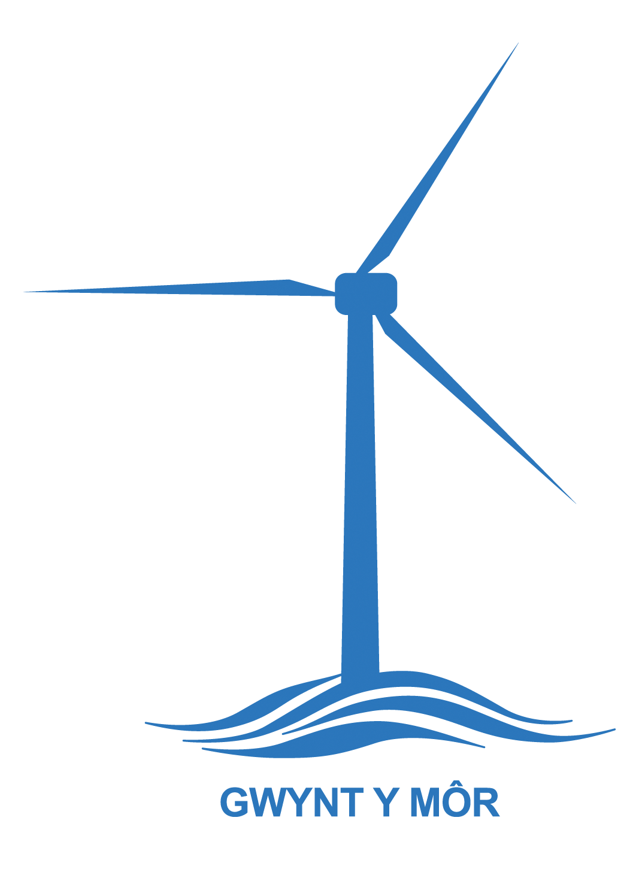Grants Team 01492 523845 email: grants@cvsc.org.uk

To find out more about how the Gwynt y Mor Community Fund is making an impact locally, visit the dedicated page on

 @NFOffshoreCF  @NWOffshoreCF

