Gwynt y Môr Community Fund
Micro Grant Application Form

Make sure you have read the Guidelines for Applicants before you complete this application.
Please apply and e-mail to us using Word Document. If you are sending a hard copy –
please write / type clearly in black or blue ink.
Please answer every question. Where the question is not appropriate to your organisation or project please write Not Applicable (N/A)

Section 1: About Your Organisation

Name of organisation

Address of your organisation | Post Code:
Project lead name
Project lead contact details | Email:  Phone:
Organisation type (Please describe your organisation’s work and structure)

Section 2: About your project

Please describe your project, why it is needed and what are the community benefits /outcomes. (What are you going to do? How many people will benefit? Does it provide volunteering opportunities?)

What are the planned project start /finish dates? | / / to / /

Section 3: Project Costs

Expenditure | Cost  £ | VAT  £ | Total  £
Total Project Costs =

Other Grants / Funds applied for or received
(Please list) =
Gwynt y Môr grant requested =

Is your Organisation registered for V.A.T.? | Yes No  If yes; you will be expected to reclaim V.A.T. on your project and any grant paid will exclude the V.A.T. element

Section 4: Project Check List

Please ensure the following documents have been included as part of your application

- Copy of organisation constitution

- Bank Statement

- Evidence/letters of community support for project (3 max)

Bank Details
Account Name:

Bank name & Address:

Sort Code: Account No.

I/we confirm that our internal financial procedures require a minimum of two signatories (must not be related) per financial transaction.

Names of authorised signatories: 1.…………………………………………………………..

2 ………………………………………………………..…
.

To be completed by a representative of the organisation/group:

I confirm that all the information on this form is true and correct.

Representative’s name: | Position:
Phone No.: | E-mail:
Signature: | Date:

Community and Voluntary Support Conwy (CVSC) operating on behalf of Gwynt y Môr, will use your personal information in order to process your funding application, and will be entered on a database utilised by CVSC and its Third Sector Support Wales partners (further information and our privacy notice are available from thirdsectorsupport.wales) . The information will be held for the length of the GYM project and then destroyed securely

Please return completed Application Form and supporting documents to:

Grants@cvsc.org.uk

Conwy/Denbighshire – Grants Team Flintshire – Heather Hicks
CVSC FLVC
7 Rhiw Road Corlan Unit 3
Colwyn Bay Mold Business Park
Conwy Wrexham Road
LL29 7TG Mold
CH7 1XP

For further help or advice please contact:
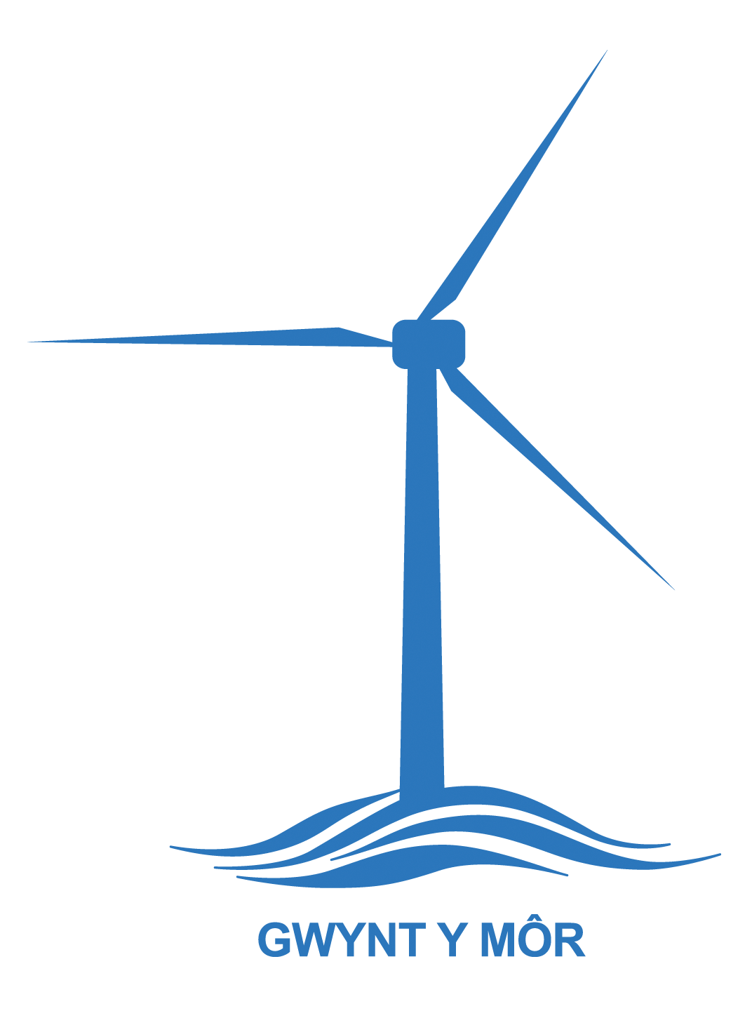
Conwy/Denbighshire Grants Team: 01492 523845, email: grants@cvsc.org.uk
Flintshire – Heather Hicks 01352 744000, email: Heather.hicks@flvc.org.uk

