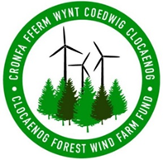
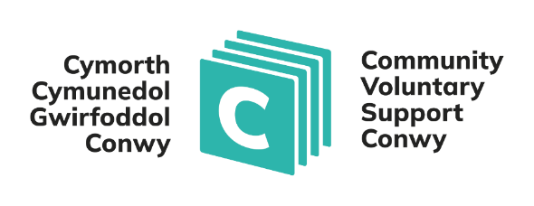

Swydd Ddisgrifiad
Teitl y Swydd: Cynorthwyydd Gweinyddol
Sefydliad: Cymorth Cymunedol a Gwirfoddol Conwy (CVSC)
Lleoliad: I’w gadarnhau
Yn atebol i: Rheolwr Grantiau a Chyllid Cynaliadwy
Oriau: Rhan-amser – 22.5 awr

Pwrpas y Rôl
Bydd y Cynorthwy-ydd Gweinyddol yn darparu cymorth gweinyddol a gweithredol cynhwysfawr i Reolwr Cronfa Fferm Wynt Coedwig Clocaenog, gan sicrhau gweinyddu, hyrwyddo a monitro'r Gronfa o ddydd i ddydd.
Bydd deiliad y swydd yn chwarae rôl allweddol wrth gefnogi prosesau grantiau, cyfarfodydd panel, cyfathrebu ac ymgysylltu â'r gymuned, gan helpu i sicrhau bod y Gronfa yn gweithredu'n effeithlon ac yn dryloyw er budd cymunedau gwledig lleol.

Prif Ddyletswyddau a Chyfrifoldebau
- Darparu cymorth gweinyddol o ansawdd uchel i Reolwr Cronfa Fferm Wynt Coedwig Clocaenog.
- Cefnogi'r gwaith o weinyddu rhaglenni grant, gan gynnwys derbyn, cofnodi, ffeilio a chadw ceisiadau am grant a dogfennaeth gysylltiedig.
- Gweithio'n agos gyda staff CCGC, gan gynnwys timau grantiau a chyllid, i sicrhau gweithrediad llyfn o weithdrefnau’r Gronfa.
- Trefnu a gweinyddu cyfarfodydd o banel y Gronfa, cyfarfodydd is-grŵp a chyfarfodydd perthnasol eraill, gan gynnwys lleoliadau, lluniaeth, papurau a logisteg.
- Cymryd cofnodion a nodiadau cywir mewn cyfarfodydd (yn Gymraeg a Saesneg) a'u cylchredeg o fewn amserlenni y cytunwyd arnynt.
- Prosesu anfonebau, hawliadau a threuliau aelodau'r panel yn unol â gweithdrefnau ariannol CCGC.
- Ymateb i ymholiadau sylfaenol am y Gronfa gan grwpiau cymunedol ac aelodau o'r cyhoedd dros y ffôn, e-bost a gohebiaeth arall.
- Trefnu a chefnogi gweithgareddau ymgysylltu â'r gymuned, megis sesiynau galw heibio a digwyddiadau "cwrdd â'r cyllidwr" o fewn ardal y Gronfa.
- Cadw cofnodion a chronfeydd data cywir ar gyfer prosiectau a ariennir, gan sicrhau bod gwybodaeth monitro yn cael ei chadw'n gyfredol.
- Cefnogi gweithgarwch cyfathrebu, gan gynnwys diweddariadau gwefan, cynnwys cyfryngau cymdeithasol a datganiadau i'r wasg, mewn cysylltiad â'r Rheolwr Cronfa a CCGC.
- Trefnu cyfieithu ysgrifenedig a chyfieithu ar y pryd ar gyfer cyfarfodydd a dogfennau, gan sicrhau darpariaeth ddwyieithog lawn.
- Mynychu cyfarfodydd a digwyddiadau yn ôl yr angen, gan gynnwys gwaith gyda'r nos neu benwythnos achlysurol.
- Ymgymryd ag unrhyw ddyletswyddau eraill y bydd Rheolwr y Gronfa yn gofyn amdanynt sy'n gyson â dyletswyddau a chyfrifoldebau'r swydd.

Sgiliau, Gwybodaeth a Phrofiad Hanfodol
- Profiad perthnasol mewn rôl weinyddol neu swyddfa.
- Siaradwr Cymraeg rhugl (llafar ac ysgrifenedig) – Cymraeg yn hanfodol ar gyfer y rôl hon.
- Gwybodaeth dda o gymunedau gwledig a’r materion sy'n effeithio ar ardaloedd gwledig.
- Sgiliau cyfathrebu cryf yn y Gymraeg a'r Saesneg.
- Sgiliau trefnu rhagorol gyda'r gallu i reoli tasgau lluosog a chwrdd â dyddiadau cau.
- Sgiliau TG da, gan gynnwys profiad o gymwysiadau Microsoft Office.
- Y gallu i weithio yn annibynnol yn unol â therfynau amser ac o dan bwysau.

- Profiad o weithio gyda neu gefnogi sefydliadau'r sector gwirfoddol a chymunedol.
- Sgiliau rhyngbersonol cryf a'r gallu i adeiladu perthnasoedd gwaith effeithiol.
- Trwydded yrru gyfredol a mynediad at gerbyd (oherwydd natur wledig y rôl).

Dymunol
- Profiad o weithio gyda rhaglenni cyllido grantiau.
- Profiad o gefnogi pwyllgorau neu baneli gwneud penderfyniadau.
- Cyfarwydd â gwaith datblygu cymunedol yng nghefn gwlad Cymru.

Cyflog ac amodau gwasanaeth
Cyflog: SCP 15 £30,024 FTE
Pensiwn: Cynllun pensiwn Llywodraeth Leol neu opsiwn pensiwn preifat ar gael.
Mae gweithwyr newydd gyda’r cwmni’n ddarostyngedig i gyfnod prawf o 6 mis. Y cyfnod o rybudd i derfynu cyflogaeth yw dau fis ar y naill ochr a'r llall.

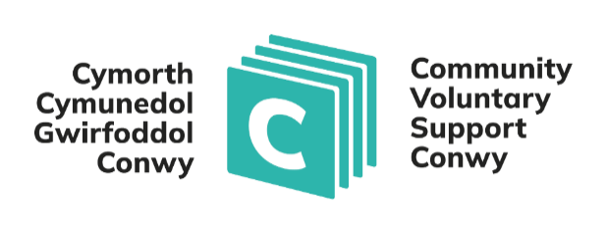

Job Description
Job Title: Administrative Assistant
Organisation: Community and Voluntary Support Conwy (CVSC)
Location: To be confirmed
Responsible to: Clocaenog Forest Wind Farm Fund Manager
Hours: Part-time – 22.5 hours

Purpose of the Role
The Administrative Assistant will provide comprehensive administrative and operational support to the Clocaenog Forest Wind Farm Fund Manager, ensuring the effective day-to-day administration, promotion and monitoring of the Fund.
The postholder will play a key role in supporting grant processes, panel meetings, communications and community engagement, helping to ensure that the Fund operates efficiently and transparently for the benefit of local rural communities.

Main Duties and Responsibilities
- Provide high-quality administrative support to the Clocaenog Forest Wind Farm Fund Manager.
- Support the administration of grant programmes, including receiving, logging, filing and keeping grant applications and related documentation.
- Work closely with CVSC staff, including grants and finance teams, to ensure smooth operation of Fund processes.
- Arrange and administer the Fund Panel meetings, sub-group meetings and other relevant meetings, including venues, refreshments, papers and logistics.
- Take accurate minutes and notes at meetings (in Welsh and English) and circulate them within agreed timescales.
- Process invoices, claims and panel member expenses in line with CVSC financial procedures.
- Respond to basic enquiries about the Fund from community groups and members of the public via telephone, email and other correspondence.
- Organise and support community engagement activities, such as drop-in sessions and “meet the funder” events within the Fund area.
- Maintain accurate records and databases for funded projects, ensuring monitoring information is kept up to date.
- Support communications activity, including website updates, social media content and press releases, in liaison with the Fund Manager and CVSC.
- Arrange written translation and simultaneous interpretation for meetings and documents, ensuring full bilingual provision.
- Attend meetings and events as required, including occasional evening or weekend work.
- Undertake any other duties consistent with the nature and level of the post as required by the Fund Manager.

Essential Skills, Knowledge and Experience
- Previous experience in an administrative or office-based role.
- Fluent Welsh speaker (spoken and written) – Welsh is essential for this role.
- Good knowledge of rural communities and the issues affecting rural areas.
- Effective communication skills in both Welsh and English.
- Excellent organisational skills with the ability to manage multiple tasks and meet deadlines.
- Good IT skills, including experience of Microsoft Office applications.
- The ability to work independently according to deadlines and under pressure.
- Experience of working with or supporting voluntary and community sector organisations.
- Strong interpersonal skills and the ability to build effective working relationships.
- A current driving licence and access to a vehicle (due to the rural nature of the role).

Desirable
- Experience of working with grant funding programmes.
- Experience of supporting committees or decision-making panels.
- Familiarity with community development work in rural Wales.

Salary and terms of service
Salary: SCP 15 - £30,024 FTE
Pension: Local Government pension scheme or private pension option available.
New employees with the company are subject to a 6-month probationary period. The notice period to terminate employment is two months on either side.

