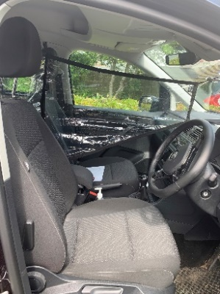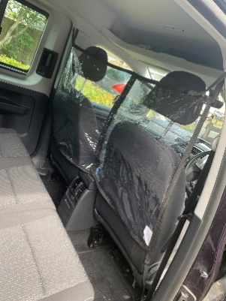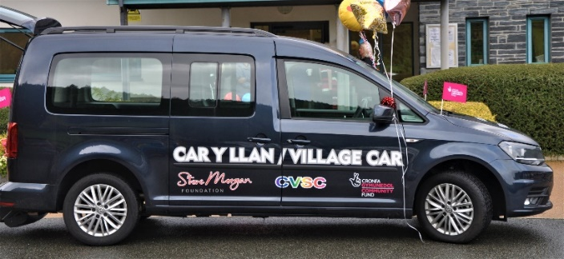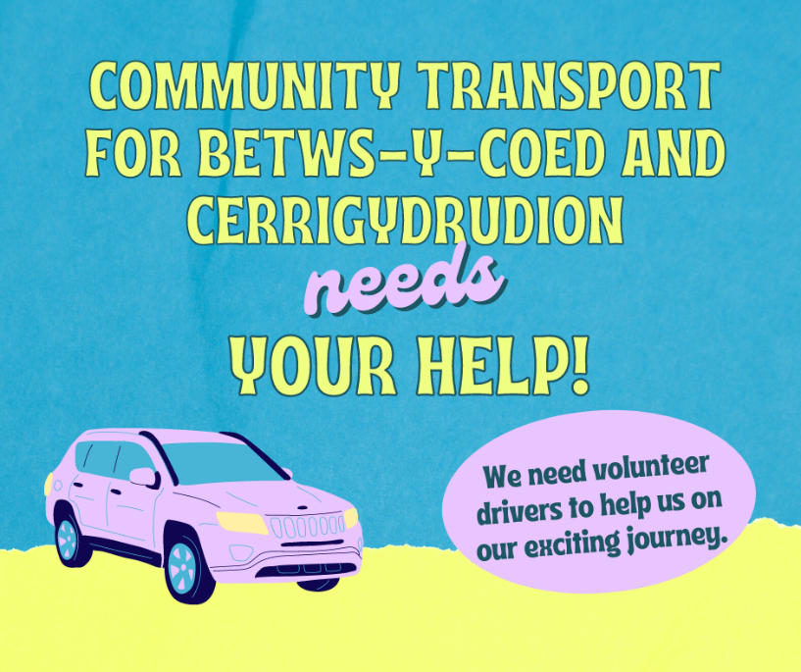

**For any more information contact me at;**

Contact number: 01492 523857

Contact Email: anniemills@cvsc.org.uk

**Are you aged over 25 years, with a clean driving license, and want to help out in your community?**

If yes then check out our wonderful opportunity where you could make a real difference to those people living in our rural areas.

Drive our lovely community car to help people residing within Betws-Y-Coed, Cerrigydrudion and the surrounding areas get to their essential appointments.

Carry out prescription deliveries for the 2 local medical surgeries if needed.

Take notes of the journey and any payments due.

Carry out regular checks on the car (full training will be given) especially at change over time, making sure the car has plenty of fuel.

**Benefits are many-** Joining a team providing help and support

Learning new transferable skills- full range of training provided

Driver and passenger safety paramount- See our new safety screen!