PROCESS FOR APPLYING FOR RIF FUNDING
CONWY AND DENBIGHSHIRE

The following process should be followed to apply for RIF funding for either expanding existing projects or developing new proposals:

We recommend that you review the attached Health and Social Care Regional Integration Fund Guidance 2022-23 Guidance criteria from Welsh Government.

Existing projects

Existing Project Investment Proposals can be updated to reflect their additional or expansion proposals. It should be clear within the PIP which are the new elements over and above existing arrangements.

New RIF projects

You must complete a Project Investment Proposal Template.

In both cases, the outline draft must contain sufficient information in terms of scope, alignment to AISB priorities, the amount being sought, as well as how you propose to ‘match fund’ (pages 30-32 in Guidance), to enable AISB to make an informed decision on whether to support the proposal.

Outline drafts need to be submitted to Llewelyn Davies at: Llewelyn.Davies2@wales.nhs.uk by 13th May 2022. You will have until 10th June to refine the detail and firm up costs and submit a final PIP to Llewelyn.

All proposals must identify how they align to the six models of care set out in the guidance (pages 16-19), and how they support the development of the ASIB priority areas within those models of care. See summary in table below.

RIF Models of Care | Area AISB Priority Areas | Existing Projects rolled forward
- Community Based Care – Prevention and Community Coordination (page 16) | - Social Prescribing and Early Intervention | - SPOA  - Disability Family Support Worker  - Progression and Prevention / Transition  - Access to Services  - Third Sector Grant
- Community Based Care – Complex Care Closer to Home (page 17) | - Community Resource Teams  - Community Support And Engagement For People Living With Dementia And Carers | - CRTs  - Community Navigators  - Falls Prevention  - Supporting Carers  - Dementia Support Workers  - Llys Elian Dementia Support Team  - DVSC Dementia Friendly  - Dementia Connect Conwy
- Promoting Good Emotional Health and Wellbeing (page 17) | - Community Wellbeing | - Community Wellbeing
- Supporting Families to Stay Together Safely, and Therapeutic Support for Care Experienced Children (page 18) | - Early Intervention Services for Children | - Strengthening Families Service  - Step Up/Step Down (LD CCN)  - Bwthyn Y Ddol (Team and Residential)  - LIFT team  - Child Development Centres
- Homes from Hospital (page 18) | - Home Based Care for Recovery and Assessment (Discharge to Recover and Assess [D2RA 2])  - Intermediate Care for Recovery and Assessment (Discharge to Recover and Assess [D2RA 3]) | - Discharge to Recover then Assess  - (Links to Colwyn Bay Integrated Health and Social Care development)  - Step Up/Step Down (Older people)
- Accommodation Based Solutions (page 19) | - Domestic or residential care and support, and supporting independent living. | - Overlap with other projects set out above e.g. Step Up/Step Down, Bwthyn Y Ddol, Colwyn Bay Integrated Health and Social Care development

NB you can only select one ‘primary model of care’ however if the proposal spans more than one model of care, you can indicate this in the ‘Any additional Models of Care’ section on page 3). AISB may amend the primary model of care to ensure alignment to programmes of work under the identified priorities.

Timeline:

The timescales for submissions and approvals are set out below.
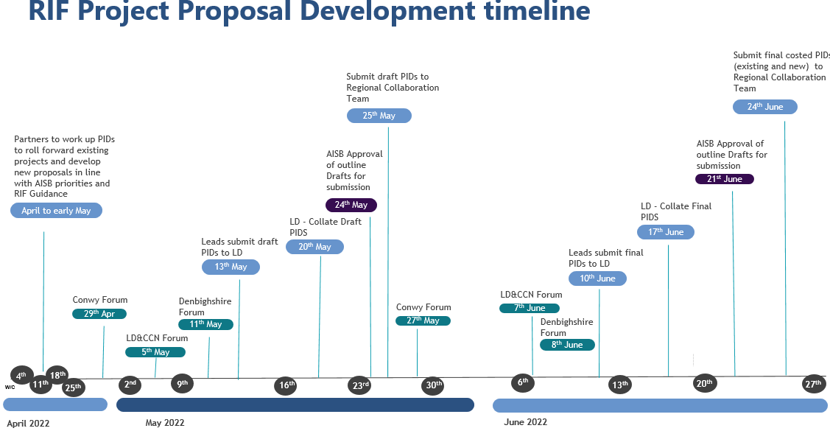

Please direct any questions to Llewelyn Davies at Llewelyn.Davies2@wales.nhs.uk.

RIF Match Funding Model: There are 4 categories of match funding (National, Acceleration, Embedding, and Core) requiring different levels of % contribution. See pages 30-32 of the Guidance:

