VOLUNTEERS’ WEEK 2020 ‘TIME TO SAY THANKS’ CAMPAIGN PACK

This pack includes

1. What is Volunteers’ Week?
2. How do volunteers contribute in Wales?
3. What are the themes for Volunteers’ Week 2020?
4. How can organisations recognise volunteers during Volunteers’ Week 2020?
5. How to get involved on social media
6. What resources are available?
a. What is Volunteers’ Week? (in 19 words, 47 words and 301 words)
b. Writing your own news item – what to include
c. Bilingual Volunteers’ Week logo and banners
d. Bilingual Volunteers’ Week email footer
e. Bilingual Volunteers’ Week certificates for individuals
f. Bilingual template letter for MP’s, celebrity patrons or supporters

7. What next?

1. What is Volunteers’ Week?

Volunteers’ Week is a UK wide and annual festival of volunteering which takes place from 1-7 June every year. This special week is a time when volunteering involving organisations are encouraged to say a huge thank you to their volunteers. Organisations that take part in Volunteers’ Week decide how best to mark the week in their own way.

The Volunteers’ Week campaign was started in 1984, which means this year marks the 36th year of formally saying ‘thank you’ to volunteers.
This year, Volunteers’ Week falls at a time of crisis, when the lives of individuals and communities have been affected by a global pandemic, when our neighbours, community members and local volunteers have become more important than ever to supporting those in need.
We think that this year, it is more important than ever for us to recognise the contribution that volunteers make, both during this crisis and in every sphere of our lives.
This year, the campaign will focus on sharing volunteering stories – highlighting the amazing things volunteers are doing at these difficult times. We also encourage organisations to not forget the volunteers that have contributed throughout the year, but that may be taking a break from volunteering right now due to the restrictions in place or a change in availability.
The key message for Volunteers’ Week will be ‘Time to Say Thanks’ and each day, from the 1 – 7 June there will be a slightly different focus.
Not able to join in this Volunteers’ Week?
Third Sector Support Wales (TSSW) recognise that many volunteer involving organisations will not be operating in the same way as usual at this time of year due to coronavirus and therefore making time to say thank you, will not be possible or may not be a priority. If this is the case, please do not feel under any pressure to take part in Volunteers’ Week 2020.
Recognising volunteers can be done at any time of the year. For information, there is an international day of volunteering on the 5th December 2020.
2. How do volunteers contribute in Wales?
Volunteers give their time, energies and skills to many aspects of life in Wales, in sports, the arts, education, health, faith-based organisations, the environment, public sectors, in the Welsh language and to a range of communities where English is a second language. Welsh villages, towns, cities, rural landscapes and the surrounding coasts and seas are improved and enhanced by volunteers that live, work, play and visit Wales. In 2018, 28% of people living in Wales reported that they volunteered1.
This year, as communities, neighbours and individuals responded to coronavirus, volunteers became involved in shopping for, and delivering food parcels, collecting and delivering items from pharmacies, providing dog walking services and being there, through providing welfare check ins and wellbeing chats to those that need them. Volunteers have raised vital funds for voluntary organisations, through a range of fundraising activities and helped share messages of public health information across social media sites.
The interest and support for volunteering in the past few months has been at an all-time high. Third Sector Support Wales is proud to share that the central online platform for volunteering (www.volunteering-wales.net) saw over 16,000 visitors from the 1 March to 27 April 2020.
Because of this, now is a good time to ensure your organisation is visible to prospective volunteers, even if your volunteer recruitment is due to be on hold for a while.

1. WCVA Data Hub -https://wcva.cymru/the-voluntary-sector-in-wales/

3. What are the themes for Volunteers’ Week 2020?

Each day of Volunteers’ Week will focus on a different aspect of volunteering to ensure we shine a spotlight on particular types of volunteering that have played a significant role in the last twelve months.

Day 1: Volunteers’ Week launch
Join the first day of Volunteers’ Week 2020 on social media. #VolunteersWeek to celebrate the start of the week. Help us trend worldwide again! Please join us for our national #ClapforVolunteers, alongside the #ClapforCarers on Thursday at 8pm.

During the day share messages of thanks from your service users, supporters or patrons. Tell us just how important your volunteers are and share how you are saying thank you.

Day 2: Volunteering in times of crisis

This year, volunteers across the UK have been out in force to support our communities at times of crisis. Thousands of volunteers stepped forward to help others during the severe floods in February and even more signed up and became part of national and local initiatives to meet the needs of people affected by coronavirus. Our national bodies and partners have never been prouder of the kindness and motivation displayed by volunteers.

During the day share case studies of volunteers that have helped during times of crisis. To include volunteers involved in locally led initiatives and those supporting the NHS and health and social care.

Day 3: Youth Volunteering
Today we’ll be placing the spotlight on youth social action. Young people aren't just the leaders of the future, they are leading and making an impact in communities all over the country, today. Let's recognise the #PowerOfYouth!

During the day invite young volunteers to share their stories and takeover your organisations social media. Share messages of thanks for the young people taking a stand in their communities to create positive change.

Day 4: Volunteer Voices
Today we want to hear directly from Volunteers. Using #IVolunteer – let’s tell the world about all the amazing ways you volunteer. We want to hear what difference you are making and what difference volunteering also makes to you.

During the day invite volunteers to share their stories about volunteering from their own perspective and get involved at 8pm as we #ClapforVolunteers (alongside the #ClapforCarers) to show gratitude to all the volunteers that have contributed to their communities over the past year and for those who have helped during the coronavirus crisis.

Day 5: Environment and conservation
To coincide with World Environment Day, we are focusing on all the environmental volunteering that takes place every day. From the smallest to the largest contributions, let us show thanks for the volunteering that makes the planet a better place.

During the day share stories of the volunteering that has supported the environment.

Day 6: Employer supported and skilled volunteers
Do you volunteer though your employer or profession? Are you an employer who supports your staff to volunteer? Do you work with employers or corporate supporters? Then today is the day to get involved and tell us all the great things you have been doing throughout the year

During the day invite those that volunteer through their employer to share the difference volunteering has made to them or encourage employers to use social media to share the ways that volunteering improves their ways of working. Ask skilled volunteers to talk about the ways that their volunteering is making a difference.

Day 7: Viewing Volunteers’ Week 2020
Let’s look back on Volunteers’ Week (and the many weeks prior to this), recognising the incredible contributions volunteers have made to their communities and say the BIGGEST THANK YOU to every single one of you – let’s keep the appreciation flowing.

During the day share your pictures of how you have showed appreciation to volunteers during the week.

4. How can organisations recognise volunteers during Volunteers Week 2020?
a. Online events and activities
There are plenty of ways you can celebrate Volunteers’ Week and express gratitude online. Here are some general guides and ideas, although you are welcome - and encouraged - to come up with your own.
b. Social media
At this time, Facebook, Twitter, and Instagram are even more important and a great way to reach followers as well as find new ones. In particular, you can
- Hold a virtual volunteer information session for prospective volunteers. Announce a time and platform in the run-up to the week and then be available at that time to answer questions. Remember to ask those taking part to tag you so you can see their queries. Twitter is a particularly good platform for this.
- Ask your volunteers to share their volunteering story online to inspire others. This works well on all platforms, but Facebook and Instagram are ideal because you can include pictures and these platforms move more slowly than Twitter so can act like a photo album.
- Create an online photo album of volunteers in action to inspire and celebrate. Facebook works well for this one as you can create an album easily: https://www.facebook.com/help/1898942430347350 Instagram is also great for sharing images, of course.
c. Meetings
Information sessions and similar meet-up ideas can also be moved to the virtual realm, perhaps via platforms which are used to conduct meetings. Some platforms which are available include webex.com and zoom.us, amongst others.
https://www.webex.com
https://zoom.us
Both of these host up to 100 people for free. You could consider holding any type of gathering via these platforms, such as a Q & A session about your organisation, a ‘mixer’ event of organisers, stakeholders, volunteers, press, etc., or a sharing event for people to swap volunteer success stories.
There are a whole host of resources available for organisations to use and our friends at Promo Cymru have developed a comprehensive list - https://www.notion.so/Digital-Resources-for-the-third-and-youth-sector-in-Wales-Covid-19-bdf7a6dcdb66478a9a3477c4cda7eaf1
d. Live streaming
It’s going to be near to impossible to live stream an event, of course, but you can still use live streaming to share elements of it - for example, if you have someone who could give a speech or tell a story relating to volunteers / volunteering, then they could self-film this via a number of platforms, for example Facebook Live or YouTube live, although there are other platforms, too (see https://blog.capterra.com/free-live-stream-tools-event/ for some ideas).
e. Recorded film
Pre-recorded film, rather than live streaming, can also be utilised at this time. Some ideas include asking volunteers to tell a positive story. You could also create a filmed thank-you letter from someone meaningful to volunteers and share this, then, both with the volunteer(s) via email and / or on one or all of your online platforms.
f. Graphics
Creating and sharing graphics to celebrate your volunteers will be important at this time. You can say thank you, share stories, celebrate triumphs, offer uplifting quotes, etc. with graphics that you can then share on social media. Online software such as canva.com is free to use and offers attractive, pre-made templates. There are other software packages available, you can easily find these by conducting an internet search.
Whatever your original ideas, try now to think of ways to move these online. We must adapt our work, at this time, and it is important that we still use Volunteers’ Week as a time to honour all those who give their enthusiasm and energy to good causes. Let us work together to make Volunteers’ Week 2020 as inspiring, uplifting, and full of gratitude as we can.

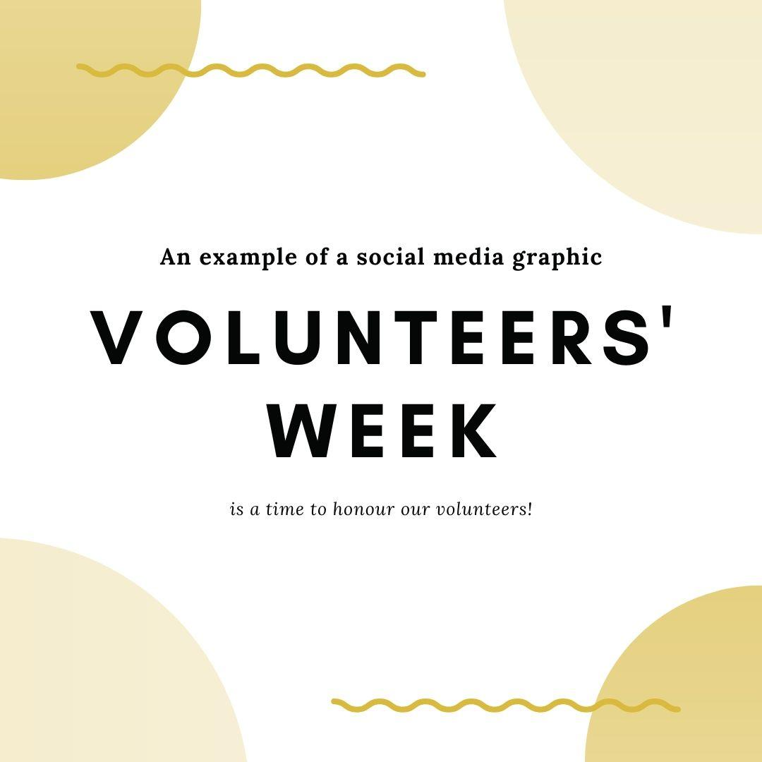

g. Certificates and thank you notes
Emails and the post are still acceptable ways to reach volunteers. Below there are template Volunteers’ Week certificates that can be completed and sent digitally to volunteers.
Saying thank you, can be as simple as sending a handwritten note or card of thanks through the post, this is a particularly good approach for those volunteers who are not likely to see messages on social media.

5. How to get involved on social media
Included below are some suggested social media posts in English and Welsh that you can use during the week.
English | Cymraeg
Prior to Volunteers’ Week | Cyn Wythnos y Gwirfoddolwyr:
We are getting ready to virtually thank all our wonderful volunteers. Make sure you tune in during Volunteers’ Week 1-7 June to find out more about our volunteers and why we will be saying a big THANK YOU! [INSERT OWN IMAGE] | Rydym ni’n paratoi i ddiolch i’n holl wirfoddolwyr gwych o bell. Gwnewch yn siŵr eich bod yn ymuno â ni yn ystod Wythnos y Gwirfoddolwyr rhwng 1 a 7 Mehefin i gael mwy o wybodaeth am wirfoddolwyr ac i gael gwybod pam byddwn ni’n dweud DIOLCH YN FAWR! [INSERT OWN IMAGE]
Did you know that the phrase ‘thank you’ stems from Latin, and loosely translates to ‘I will remember what you have done for me’? Join us during Volunteers’ Week when we will be saying thank you to the volunteers that have done great things for us. [INSERT OWN IMAGE] | Oeddech chi’n gwybod bod y term ‘thank you’ yn dod o’r Lladin, a’i fod yn golygu ‘Mi gofia’ i beth rwyt ti wedi’i wneud i mi’? Ymunwch â ni yn ystod Wythnos y Gwirfoddolwyr, pan fyddwn yn diolch i’r gwirfoddolwyr sydd wedi gwneud pethau gwych ar ein cyfer ni. [INSERT OWN IMAGE]
Day 1: Volunteers Week Launch (#VolunteersWeek) | Diwrnod 1: Lansio Wythnos y Gwirfoddolwyr (#WythnosyGwirfoddolwyr)
Let’s kick off Volunteers’ Week with a photo of our volunteers in action from [earlier in the year / last year] [INSERT IMAGE OF VOLUNTEERS] | Beth am ddechrau Wythnos y Gwirfoddolwyr gyda llun o’ch gwirfoddolwyr ar waith [yn gynharach eleni / y llynedd] [INSERT IMAGE OF VOLUNTEERS]
Today marks the start of Volunteers’ Week, here is a message from [INSERT NAME AND MESSAGE FROM A SOMEONE YOUR VOLUNTEERS VALUE] | Heddiw yw diwrnod cyntaf Wythnos y Gwirfoddolwyr. Dyma neges gan [INSERT NAME AND MESSAGE FROM A SOMEONE YOUR VOLUNTEERS VALUE]
Day 2: Volunteering in times of crisis | Diwrnod 2: Gwirfoddoli mewn argyfwng
Volunteers across Wales have been there to support in times of crisis. Our organisation would like to say ‘THANK YOU’ to all the volunteers that have been there when Wales has needed you the most. [INSERT OWN MESSAGE OR IMAGE OF THANKS] | Mae gwirfoddolwyr ledled Cymru wedi bod yno i gefnogi pobl yn ystod cyfnodau o argyfwng. Hoffai ein mudiad ni ddweud ‘DIOLCH YN FAWR’ wrth yr holl wirfoddolwyr sydd wedi bod yno pan oedd eich angen ar Gymru yn fwy nag erioed. [INSERT OWN MESSAGE OR IMAGE OF THANKS]
Day 3: Youth Volunteering (#PowerofYouth) | Diwrnod 3: Gwirfoddolwyr Ifanc (#GrymIeuenctid)
Young people of Wales have demonstrated the #PowerofYouth in our organisation. Thank you. [INSERT OWN MESSAGE OR IMAGE OF THANKS] | Mae pobl ifanc Cymru wedi dangos #GrymIeuenctid yn ein mudiad ni. Diolch. [INSERT OWN MESSAGE OR IMAGE OF THANKS]
Thank you to the young people at [INSERT NAME OF ORGANISATION] that have stepped up to say #iwill. [INSERT OWN MESSAGE OR IMAGE] | Diolch i’r bobl ifanc yn [INSERT NAME OF ORGANISATION] sydd wedi camu i'r adwy i ddweud #fewnafi #iwill. [INSERT OWN MESSAGE OR IMAGE]
Day 4: Volunteer Voices  (#IVolunteer) | Diwrnod 4: Lleisiau Gwirfoddolwyr  (#DwinGwirfoddoli)
Here is one of our volunteers sharing why they volunteer with us. Thank you. Remember to join the #ClapforVolunteers at 8pm this evening. [INSERT MESSAGE FROM A VOLUNTEER] | Dyma un o’n gwirfoddolwyr ni’n rhannu pam mae’n gwirfoddoli gyda ni. Diolch. Cofiwch ymuno yn yr ymgyrch #ClapforVolunteers am 8pm heno. [INSERT MESSAGE FROM A VOLUNTEER]
Tell us why you volunteer this #VolunteersWeek and use the hashtag #IVolunteer. We hope you will also join us for the #ClapforVolunteers at 8pm tonight. [INSERT OWN MESSAGE OR IMAGE] | Dywedwch wrthym ni pam rydych chi’n gwirfoddoli yn ystod #WythnosyGwirfoddolwyr eleni a defnyddiwch yr hashnod #DwinGwirfoddoli. Rydym ni’n gobeithio y byddwch chi’n ymuno â ni ar gyfer y digwyddiad #ClapforVolunteers am 8pm heno. [INSERT OWN MESSAGE OR IMAGE]
Day 5: Environment and conservation (#WorldEnvironmentDay) | Diwrnod 5: Yr Amgylchedd a chadwraeth (#DiwrnodAmgylcheddyByd)
Volunteering is great for the planet. Look what our volunteers have been up this year [INSERT IMAGE OR FILM OF ENVIRONMENTAL VOLUNTEERING] | Mae gwirfoddoli’n gwneud lles i'r blaned. Edrychwch ar beth mae ein gwirfoddolwyr ni wedi bod yn ei wneud eleni [INSERT IMAGE OR FILM OF ENVIRONMENTAL VOLUNTEERING]
Day 6: Employer supported and skilled volunteers (#EmployerSupportedVolunteering #SkilledVolunteers) | Diwrnod 6: Gwirfoddolwyr medrus a gwirfoddolwyr sy’n cael eu cefnogi gan gyflogwyr (#GwirfoddoliGydaChymorthCyflogwr #GwirfoddolwyrMedrus)
Our organisation is a champion for #EmployerSupportedVolunteering. This year we have enabled XX members of staff to give XX hours to support the communities of Wales | Mae ein mudiad ni’n hyrwyddo #GwirfoddoliGydaChymorthCyflogwr. Eleni, rydym ni wedi galluogi XX aelod o staff i gyfrannu XX awr i gefnogi cymunedau Cymru
#SkilledVolunteers in our organisation make all the difference. Thank you. [INSERT OWN MESSAGE OR IMAGE OF THANKS] | Mae #GwirfoddolwyrMedrus yn ein mudiad yn gwneud gwahaniaeth mawr. Diolch. [INSERT OWN MESSAGE OR IMAGE OF THANKS]
Day 7: Viewing Volunteers’ Week 2020 (#VolunteersWeek) | Diwrnod 7: Cipolwg ar Wythnos y Gwirfoddolwyr 2020 (#WythnosyGwirfoddolwyr)
This is what we did to say ‘THANK YOU’ to our volunteers this week.  [INSERT OWN MESSAGE OR IMAGE] | Dyma beth wnaethom ni i ddweud ‘DIOLCH’ wrth ein gwirfoddolwyr yr wythnos hon.  [INSERT OWN MESSAGE OR IMAGE]
Looking to recruit volunteers? Find out how to create a quality volunteering project by visiting the resources we have available [INSERT LINK TO RESOURCES] | Ydych chi eisiau recriwtio gwirfoddolwyr? Ewch i weld sut mae creu prosiect gwirfoddoli o ansawdd da drwy edrych ar yr adnoddau sydd ar gael gennym ni [INSERT LINK TO RESOURCES]
Inspired to get involved in volunteering? Find out more and search hundreds of opportunities at www.volunteering-wales.net [INSERT OWN MESSAGE OR IMAGE] | Ydych chi wedi cael eich ysbrydoli i wirfoddoli? Ewch i gael rhagor o wybodaeth a chwilio drwy gannoedd o gyfleoedd yn www.volunteering-wales.net [INSERT OWN MESSAGE OR IMAGE]

6. What resources are available?
a. What is Volunteers’ Week (in 19 words, 47 words and 301 words)
In 19 words
Volunteers’ Week is a UK wide and annual festival of volunteering which takes place from 1-7 June every year.
In 47 words
Volunteers’ Week is a UK wide and annual festival of volunteering which takes place from 1-7 June every year. The Volunteers’ Week campaign was started in 1984 and is a special week when volunteering involving organisations are encouraged to say a huge thank you to their volunteers.
In 301 words
Volunteers’ Week is a UK wide and annual festival of volunteering which takes place from 1-7 June every year. The Volunteers’ Week campaign is a special week when volunteering involving organisations are encouraged to say a huge thank you to their volunteers.
Volunteers are central to the work of countless charities and other organisations. They are a valuable presence in many communities, making a difference in places as diverse as sports clubs, libraries, schools, woodlands and hospitals.
In 2020, hundreds of thousands of volunteers stepped up to support others in times of crisis. First, as towns and cities across the UK faced severe flooding, emergency volunteers came to the rescue of people trapped in homes and supported the clean-up operation. And, second, volunteers supported those affected by coronavirus, volunteering to deliver food parcels and being available at the end of a phone for those facing long periods of being alone. This year, the Volunteers Week campaign will predominantly take place online and will include a #ClapforVolunteers (alongside the #ClapforCarers) event at 8pm on Thursday 4 June as a nationwide expression of thanks for volunteers. The annual campaign, which was established in 1984, recognises the contribution volunteers make to our communities every day. This year, recognition of our nation’s volunteers is more important than ever.
It is hoped that all individuals, across all sectors of Wales will unite to share messages to thank volunteers and celebrate the power of volunteering to bring communities together and to be there when needed.
For many volunteer involving organisations, the week will also be a chance to inform prospective volunteers of the range of volunteering opportunities throughout the year. Those interested will be invited to visit the online volunteering platforms available in each nation to see what is available. In Wales, individuals are invited to visit www.volunteering-wales.net.
b. Writing your own news item – what to include
- Background on your organisation – who you are and what you do
- What it means to you, your staff and volunteers to work or volunteer with the organisation
- A quote or two from staff and/or volunteers
- An image in jpeg (with permission to use on various websites if appropriate)
- Social media links: Twitter, Facebook, Instagram (etc) details
- Contact details (e.g. If you’d like to volunteer with the organisation, contact……)
- Web address
- Any plans you may have for the future

c. Bilingual Volunteers’ Week logos and banners
The bilingual logos and banners can be downloaded from the WCVA Volunteering pages.
d. Bilingual Volunteers’ Week email footer
The bilingual email footer can be downloaded from the WCVA Volunteering pages.
e. Bilingual Volunteers’ Week certificates for individuals
The bilingual Volunteers’ Week certificates for individuals can be downloaded from the WCVA Volunteering pages.
f. Bilingual Volunteers’ Week certificates for groups
The bilingual Volunteers’ Week certificates for groups can be downloaded from the WCVA Volunteering pages.
g. Bilingual template letter to MP’s, celebrity patrons or supporters
The bilingual template letter to MP’s, celebrity patrons or supporters can be downloaded from the WCVA Volunteering pages.

7. What next?
Third Sector Support Wales (TSSW) are keen to hear about how you will be saying thank you to your volunteers this year. Please contact your local County Voluntary Council (CVC) or WCVA to let us know what you have planned.
We will also be encouraging organisations to share a case study of how they have expressed gratitude to volunteers for Volunteers Week 2020. If you would like to share what your organisation did this year to express your gratitude to volunteers, please complete the case study template available on the WCVA Volunteering pages and send it to volunteering@wcva.cymru
Thank you for taking the time to say thank you!

