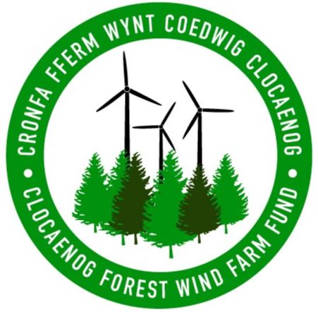

How do I apply to be on the panel?
Please visit www.cvsc.org.uk/clocaenog where you will find a panel role description as well as an application form.

I don’t have previous experience of grant making, can I still apply to be on the panel?
Yes, we are looking to recruit a panel that is representative of the whole community, therefore panel members may be young, old, working, retired or unemployed or from a wide range of backgrounds. The more mixed and diverse the panel, the more representative of the local community is likely to be. We are keen to involve people with knowledge and understanding of what is already happening in the area as well as people with new and innovative ideas. There are a whole range of other skills that are likely to be beneficial to the panel, Maybe you have skills and experience in business, working with young people or running your own community projects?

Will panel members be paid?
Joining the panel is a voluntary role, but travel expenses would be covered.

How do I apply to the fund?
The fund is not currently open for applications. It will open until the panel has been appointed so that they have the opportunity to be fully involved in shaping the funds design it is anticipated the fund will be open in the summer.

Is my project in the right location to be eligible to apply for the fund?
Please visit www.cvsc.org.uk/clocaenog to view the full area of benefit for the fund where you can see if you project is based within one of the eligible zones.

Will my project be eligible to apply when the fund opens?
We can’t answer this question just yet, because we want the panel to be involved in the final design of the criteria. We will aim to keep the fund as flexible as possible, to make sure that projects that really make a difference to the local area can be supported.

How do I keep up to date with further announcements about the fund, including when it will be open for applications?
Please visit https://www.cvsc.org.uk/en/funding/clocaenog where all updates about the fund will be published. If you would like to receive e-mail updates you can also contact CVSC at mail@cvsc.org.uk and ask to be added to their e-mail update list.

Is the fund already accruing money?
The first payment to the administrator is about to be made and will continue to be paid at quarterly intervals throughout the lifetime of the wind farm.

